Welcome DREAMER to the Journal to accompany NOW IS YOUR TIME a no bullsh!t guide for dreamers and doers!! If you are reading the online version I highly suggest printing these exercises out to allow yourself the opportunity to participate as you read! If you have the printed version of my book, allow this workbook to offer you unlimited space to journal and express freely! I am so excited about where you are on your path and I am here to support your journey! The universe is waiting for you to share your gifts and passion with the world! Cheers to you for making the choice to dive deeper!! Sending you my love.

Ch2. This Is Because of My Circumstance, I Played No Part
Guided Journal Exercises

Questions for reflection: Where it all began
What is your family life like?

Who were the individuals in your family that inspired you at a young age?

Describe the best day of your life as a child…do you remember what you were wearing? What made it so special?

Questions for reflection: The School Days
What hobbies did you have as a child? What did you LOVE to do?

Can you recall areas where you stood out or excelled as a child?

Were you ever told you weren’t good enough by someone you respected? A teacher, a parent, a coach?

Questions for reflection: Things Take a Turn
Can you recall a time in your life when everything seemed perfect and then Wam..life happened in an unexpected way?

How you ever thought you had more control over someone or a situation than you actually did? How did you come to the realization that it was out of your control?

Have you ever had a moment where you felt like this doesn’t happen to me or my family..this kind of stuff happens to others?

Questions for reflection: After Graduation
Have you ever wanted something more for someone than they wanted for themselves?

Have you ever struggled with your role in a relationship..maybe a sibling you tried to parent or a friend you tried to parent or even a parent you tried to parent?

Were you ever convinced the problem was others and then realized you were contributing to the dynamics more than you realized?
Are there possibly problematic relationships in your current life that you could see from a different perspective?

Questions for reflection: RUNNING AWAY
What do you like to do when you are alone?

Have you ever thought others were the cause of your unhappiness only to step back and realize if you had set better boundaries all your pain could have been avoided?

Have you ever thought..well, I shouldn’t have to tell him or her not to take advantage of me?

Have you ever made a purchase when you are lonely looking to find fulfillment?

Questions for reflection: My Journey Down a Dead-end Road
Have you ever been turned down, fired, etc and later realize it was such a blessing?

Name a time you let fear stand in the way of what you really wanted.

Have you ever taken on a job or career that was not in alignment with your goals? What were some of the reasons you told yourself why? What were the real reasons?

Questions for reflection: RESTORING FAITH THROUGH LOSS
Have you ever experienced a moment that made you realize you were no longer a child?

Have you ever tested fate? How or when?

Have you had an opportunity to find the beauty in loss?

Questions for reflection: ANOTHER DETOUR JUST FOR FUN
Have you ever gotten caught doing something and felt like you were drowning in self shame?

Have you ever made a mistake and tried to hide it from your parents so not to disappoint them?

How have you let a mistake from your past make you a better person moving forward?

Questions for reflection: LOOK MOM NO HANDS..almost
Name a time you had a blast and you were alone? What were you doing?

Describe a time you have had an epiphany or heard that voice inside you directing you.

Have you ever made the same mistake twice or uncovered a pattern you find yourself stuck in?

Ch.3 WHO ARE YOU REALLY AND WHAT DO YOU WANT

Identify 5 of your strengths, gifts, and talents below
1.
2.
3.
4.
5.

Guided meditation : double click on the image of the speaker to listen

I want you to look over the words you wrote or have bullet pointed down. I now want you to answer these questions…
How will your life change the world?

How do you want to be remembered?

Write your mission statement below:

Your excuses
1.
2.
3.
4.
5.
CH4. Taking Care of YOU, So You Can Take Care of Others

5 accomplishments
1.
2.
3.
4.
5

BALANCE CIRCLE
Fill out the balance circle. Keep in mind there are imaginary tick marks from 0-10 0 being closest to the center and 10 being furthest away. Be honest with yourself as this exercise is for you and your happiness.
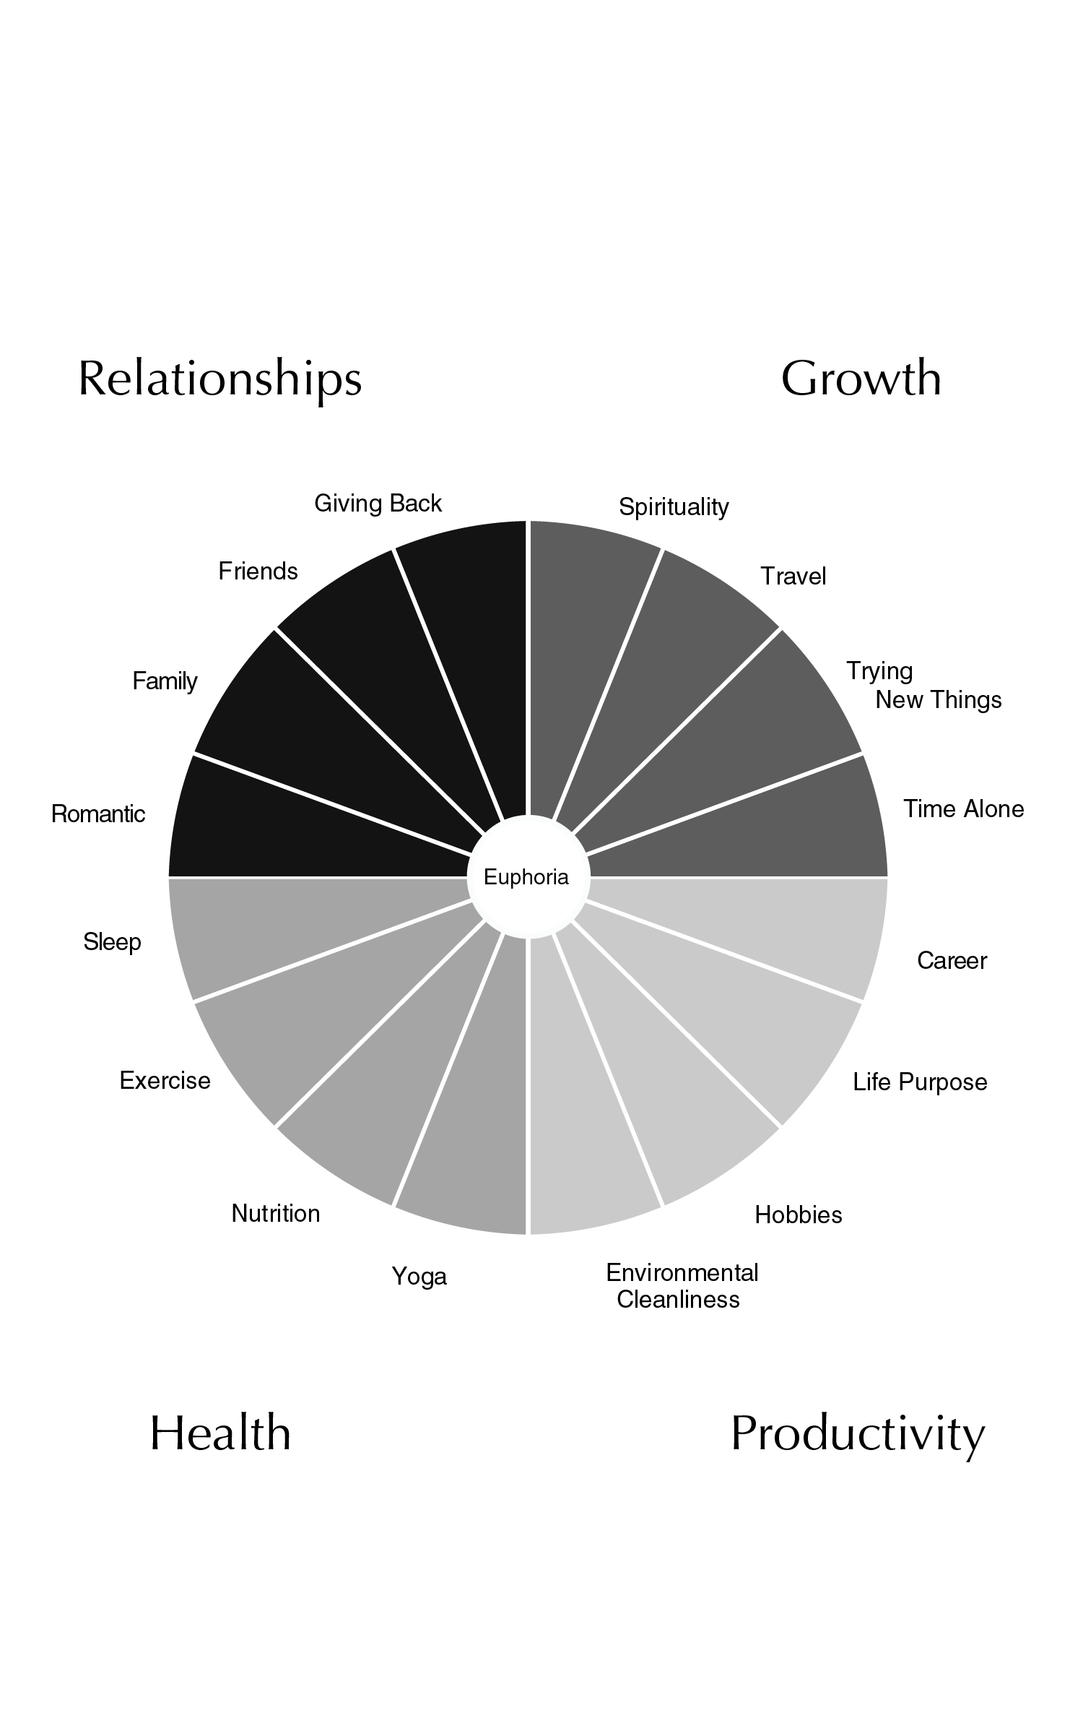
Now let’s look at the areas that could use some adjusting. Ideally every category is a 5. We do not want any one area to be a 10 consuming all of our energy or any area at a zero. The only exceptions are if currently you do not have a Romantic relationship then simply omit it from the equation or if you are one of the select few whose Life Purpose and Career are currently one in the same. Below you will find each category and subcategory. Circle the areas you find that are not ranked 4-6 range. We want to give attention to any area you ranked 0-3 or 7-10.
Relationships:
Romantic
Family
Friends
Giving Back

Growth:
Spirituality
Travel
Trying New Things
Time Alone

Productivity:
Career
Life purpose
Hobbies
Environmental Cleanliness

Health:
Yoga
Nutrition
Exercise
Sleep
Now that we have established areas that need our attention let’s distinguish between the ones that need less of our attention and the areas that need some love. Any category that you currently find to be consuming more of your attention 7-10, I want you to think of ways you can slowly back off of this. For many of my highly successful clients Career is an easy one to become hyper focused on. Remember we need balance in our lives. Think of 3 ways you could devote less time in this area if it is a Career for you may be you determine you will not answer email, texts, calls, or anything from the office from the hours of 7pm-7am. Whatever category it is for you think of 3 ways you can free up some more of your time in that area.
1.

2.

3.

Perfect! Now let’s look at the areas you ranked 0-3 category that need a little love. I want you to think about a few places you’d like to start. The goal of this exercise is NOT to OVERWHELM. So please if you have 4 areas that need some attention do not try to do a million things to up the anti all at once. We are going for balance here. Let’s be kind to ourselves in the process. Looking at the subcategories ranked 0-3, list a few easy ways you could start showing them love today.
1.

2.

3.

If you are having trouble thinking of easy ways to begin to incorporate more of a subcategory consider my suggestions below. Here I have laid out each subcategory and listed ideas on how to begin to incorporate each one into your daily life. First consider improving any area you gave a 0-3 ranking. See below for ideas!!

Relationships

Romantic
-plan a date night
-choose a day of the week or time of day that you devote solely to being present with this individual
-Learn the “love language” of your partner and be sure that your efforts for displaying love are in alignment with how they see and experience love

Family
-organize a family game night or dinner out
-think of an activity you all do together away from electronics to stimulate meaning conversation and interactions
-set up weekly or biweekly skype or phone dates if you live further away

Friends
-ask a friend to go for a walk, visit in the park, or meet for coffee
-connect with your friends over a dinner out
-I personally love to invite my girlfriends to join me for a weekly yoga date

Giving Back- involves your time and human interaction
-reading or tutoring at the local Boys and Girls Club
-volunteering at local food pantry
-assistant teaching, tutoring, or coaching at a nearby school
-taking part in Big Brothers Big Sisters program
-consider how your gifts and talents could help someone in need that lives in your community ex. Teaching free guitar lessons to a child who cannot afford them
-consider foster care for a local pet shelter

Growth:

Spirituality
-meditation-guided meditation cds or apps on your phone
-Deepak Chopra offers some guided mediation courses
-prayer
-write a letter to a loved one who has passed

Travel
-if you can’t find a large block of time to get away then consider a weekend trip to a nearby city or place you don’t often spend time
-if you are unable to sneak away to someplace tropical, try visiting TripAdvisor, search your city…find some ideas of places you have yet to experience in your own city!

Trying New Things
-plan a date night or girls night out to a place or activity you’ve never tried
-add 3 new items to your cart at the grocery store
-go to your favorite restaurant and order something you have never tried off the menu
-begin to say “yes” when offered something you have yet to experience
-look up a new workout you haven’t tried ex. Hoop class, aerial yoga, spin, TRX, etc
-if you are traveling for work, friends, wedding, or city you’ve been to countless times, look on Trip Advisor for suggestions of “must do” “must see” “must try” places and things…see if any are things you have yet to experience and try one or two
-sign up for a class at your nearby community arts center

Time Alone- time away from electronic devices or noise of any kind
-meditation
-journaling
-long road trip
-hike-listen to the birds
-walk-when your mind wonders to your “to do” list bring it back to the sounds of nature around you
-run-without phone or music
-READING LIST

The 5 Love Languages by Gary Chapman

Strengths Finder by Tom Rath

Finding Your Own North Star by Martha Beck

The Secret by Rhonda Byrne

The Four Agreements by Don Miguel Ruiz

Loving What is by Bryon Katie

The Happiness Advantage by Shawn Achor

The Happiness Trap by Russ Harris
-coloring pages!!! I have added a few links to some awesome free color page templates…buy some markers and go nuts!
http://www.coloring-pages-adults.com
http://www.easypeasyandfun.com/free-coloring-pages-for-adults/
http://www.thecountrychiccottage.net/2015/07/25-free-adult-coloring-pages.html

Productivity:

Career

-if you are having a difficult time staying positive about your career and if you are feeling a strong urge to do something else I highly suggest beginning to think of ways you can spend less time in the office or begin to look for a job that will offer you comparable income while you transition to your life purpose..If this seems overwhelming or confusing set up a complimentary call with me www.talktosteph.com

Life purpose
-if you are not currently being paid to execute your life purpose find a way to participate in activities you enjoy that will nurture and support you in the development of your purpose

Hobbies
-if you feel like you are lacking in hobbies then think about something you have always wanted to try and or take a class in and never have, then research classes being offered in your area ex. Calligraphy, Story Telling, Improv, photography, etc

Environmental Cleanliness
-I find it best to build tidying up and cleaning into my schedule, for example I tidy up before bed each evening and do my deep cleans every other Sunday

Health:

Yoga- at a studio or in your home
-you can watch videos online
-find a local studio.. I highly suggest starting with a Flow or Deep Stretch class as your introduction to yoga. Hot Yoga, Vinyasa, and Power may be a little intense for your first experience

Nutrition
-easy places to start…if you drink soda begin to tailor it back (yes even diet soda)
-if you aren’t consuming at least 8 glasses of water a day-buy a water bottle you can carry around with you throughout your day
-if you know a certain food upsets your stomach try eliminating it completely from your diet for a week…see how you feel
-if you aren’t already, consider taking a multivitamin
-if you are struggling to achieve your recommended daily amount of fruits and vegetables ..like most of the world then try to incorporate just one more serving than usual
-green leafy veggies are the best for you however, if you are currently not taking in any vegetables consider something easy like a bag of carrots to take with you in the AM and snack on throughout the day

Exercise-at least 30min of elevated heart rate
-TRX, HITT, running, and Spinning are all great suggestions to get your heart rate up

Sleep- 7-8 hrs a night regularly
-consider purchasing a device to wear on your wrist to track your sleep

Now I want you to list the areas you are dedicated to adjusting. Next to the area of adjustment make note of an idea or two that you have thought of or chosen from suggestions above as to the ways you are going to implement that change.

ex. 1. Yoga/stretching-join a challenge or create your own
ex 2. Sleep-buy a device and begin recording your sleep

1.
2.
3.
4.
5.

CH.5 Oh Wait My Work is Not Over?
I want you to think of a play list. Think of positive songs with awesome messages that will remind you of your mission on the hard days.
1.
2.
3.
4.
5.

Write down 3 reasons why NOW is not only the right time for you to get started but the only time…
1.
2.
3.

